**Practical-1**

**Aim:-**Using the tools for WHOis, traceroute, email tracking.

**Step 1:** Open the WHOis website.

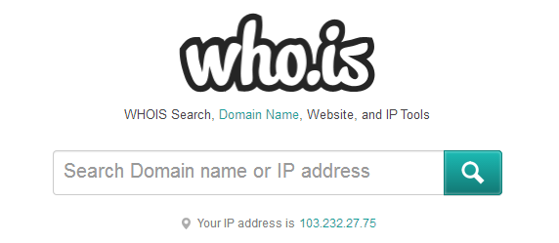

**Step 2:** Enter the website name and hit the “enter button”.

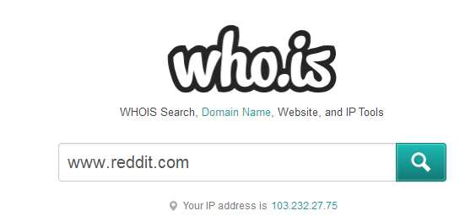

**Step 3:** Show you information about reddit.com in whois tab.

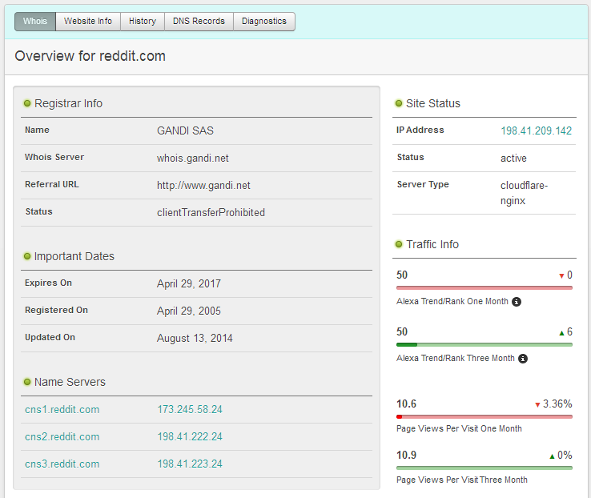

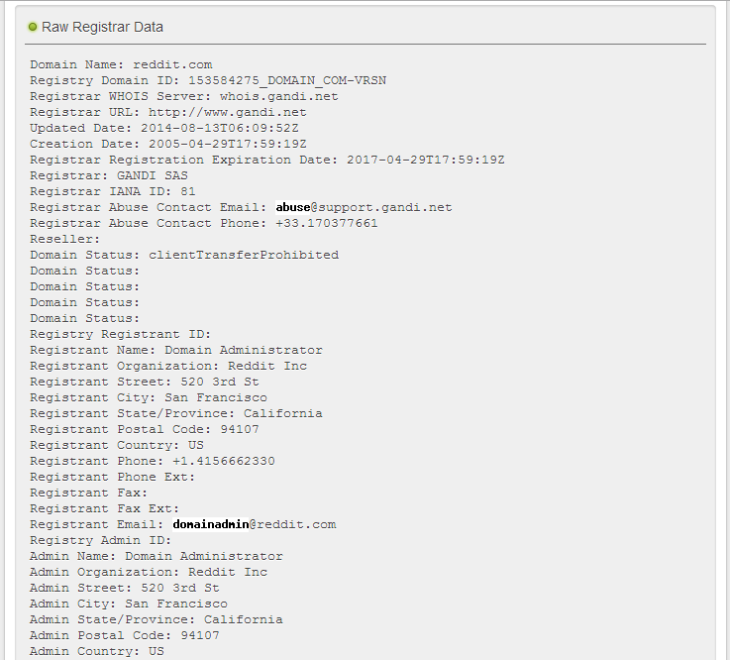

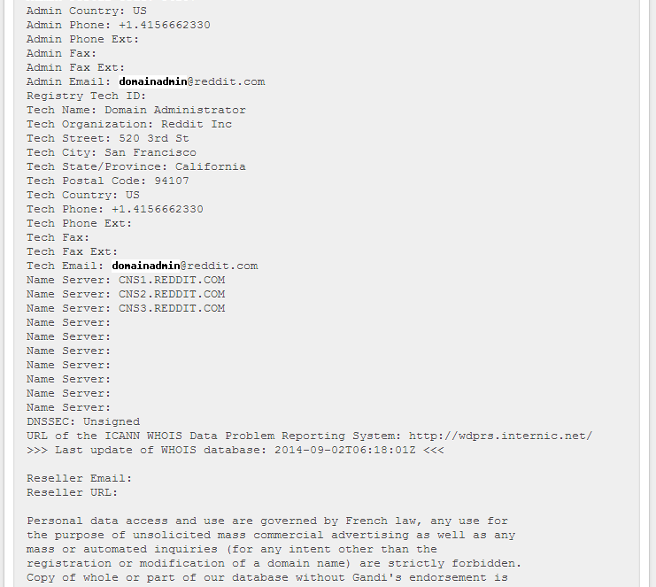

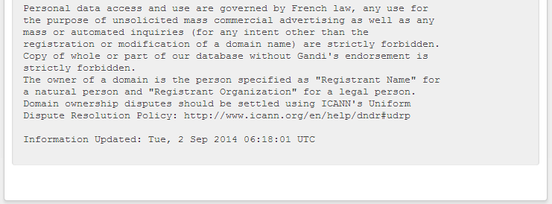

**Step 4:** Show you information about reddit.com in website information tab

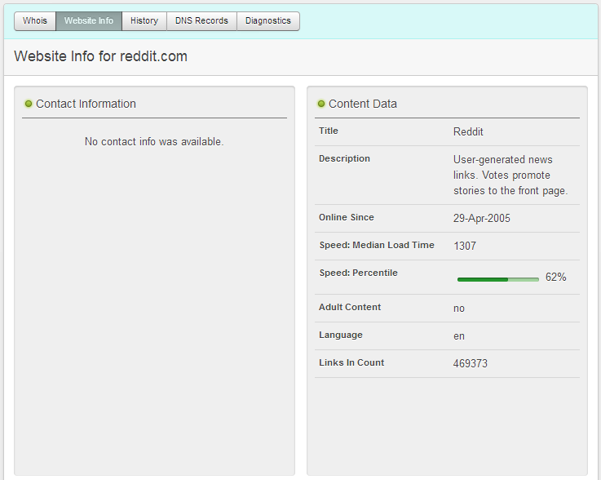







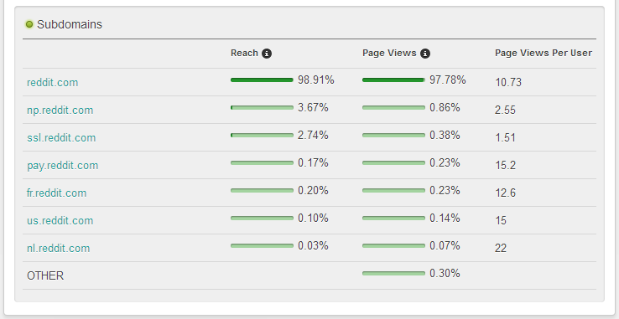

**Step 5:** Show you information about reddit.com in history tab.

g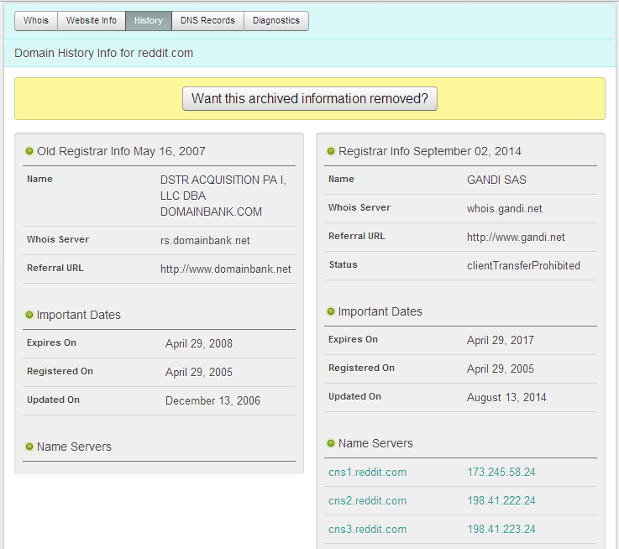

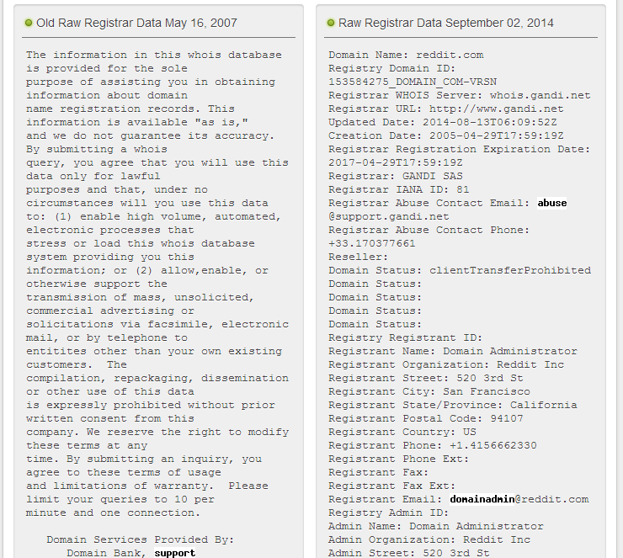

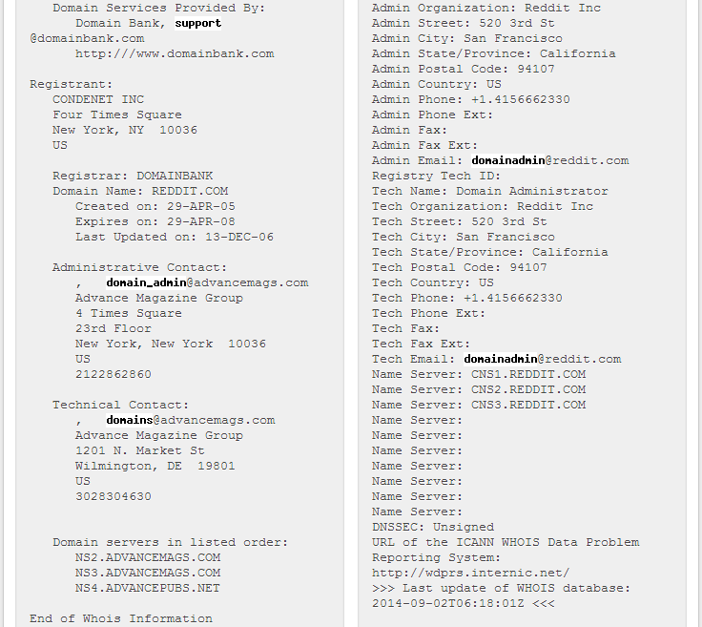

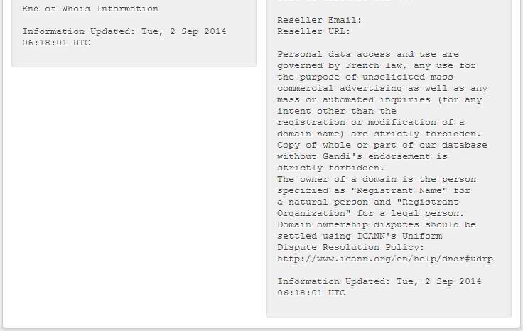

**Step 6:** Show you information about reddit.com in dns records tab.

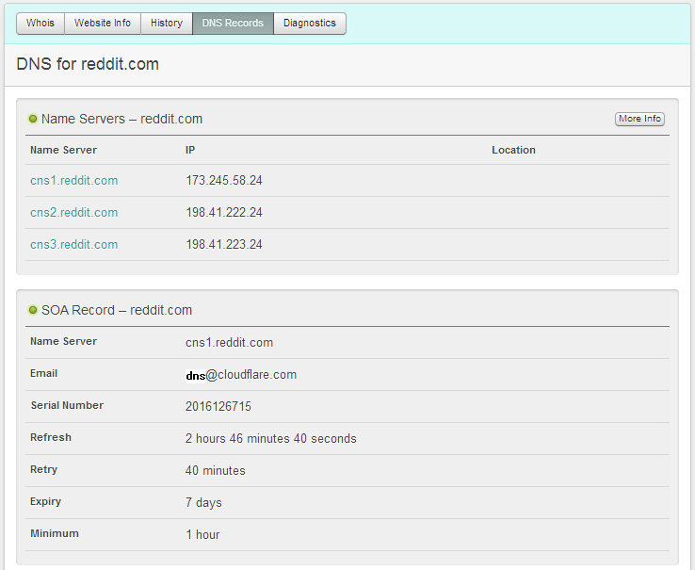

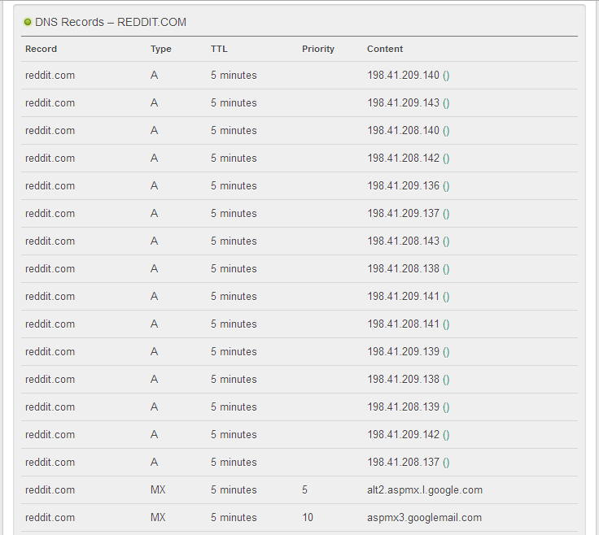

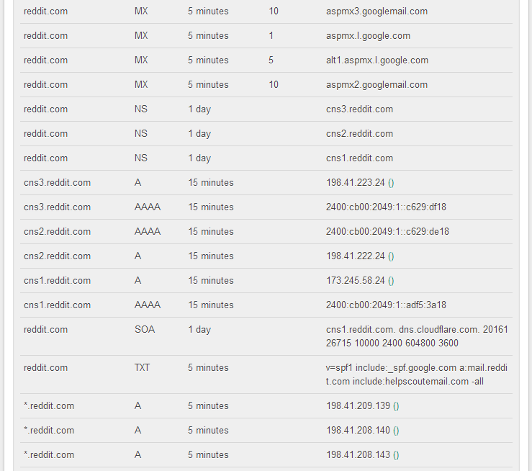

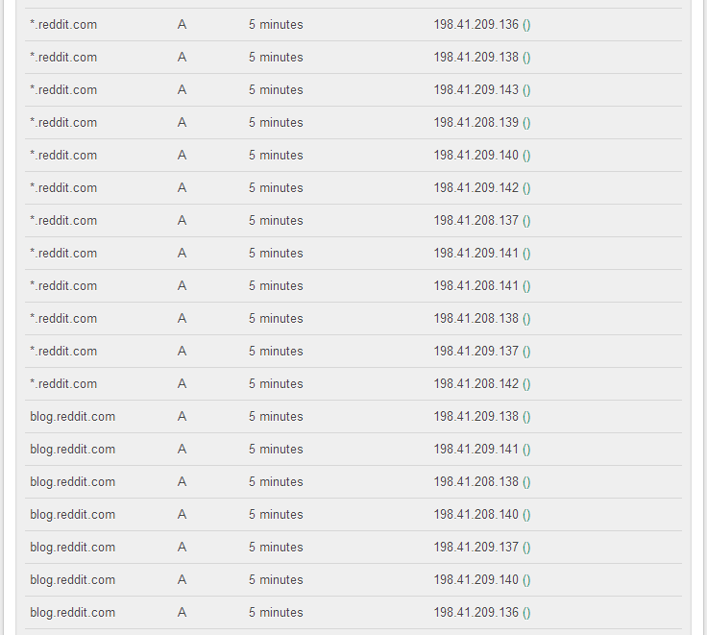

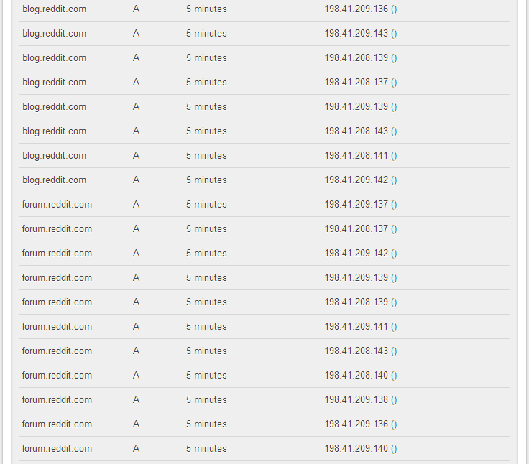

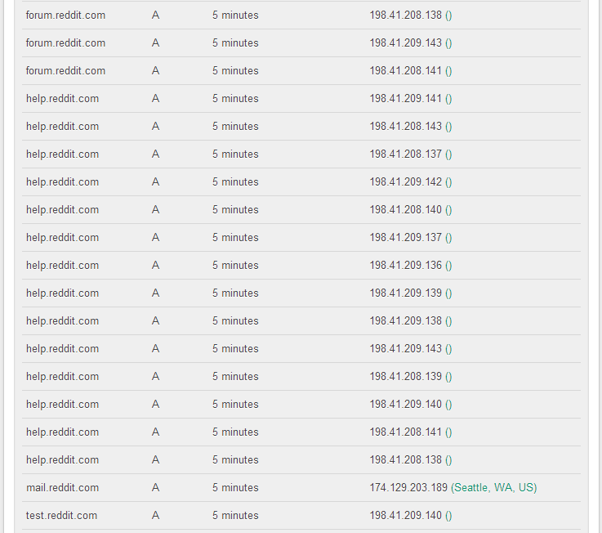

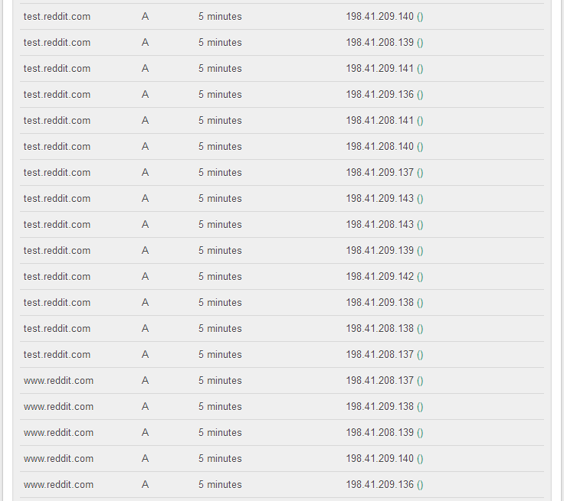

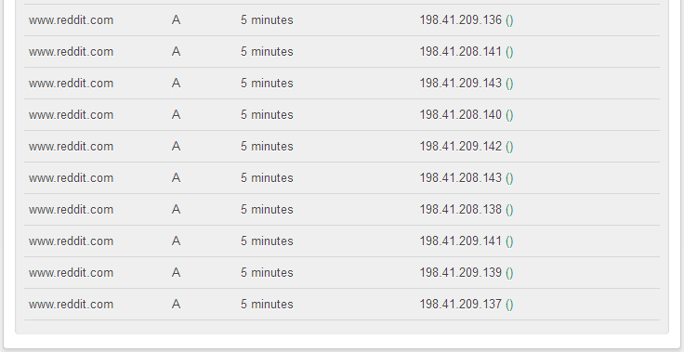

**Step 7:** Show you information about reddit.com in diagnosis tab.

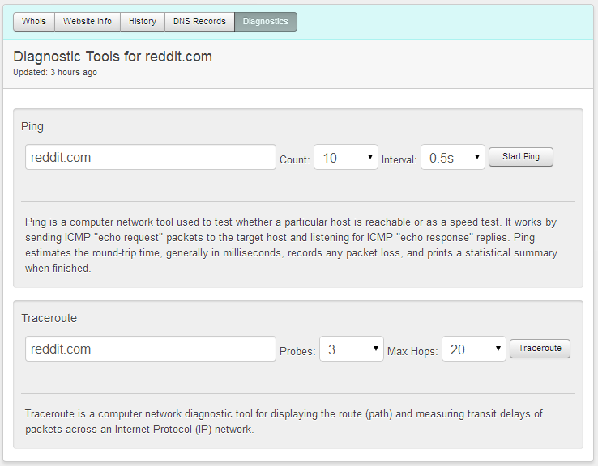

**USING TRACE ROUTE**

**Step 1:** Open cmd prompt.

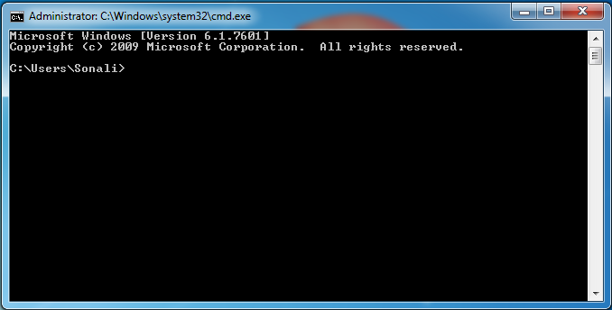

**Step 2:** Type cd\ and enter it will redirect to “C/directory”.

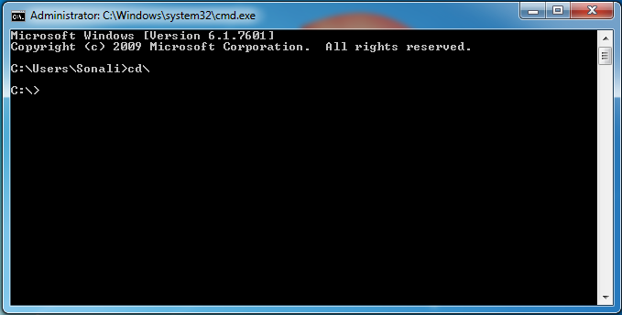

**Step 3:** Type tracert command and type [www.reddit.com](http://www.reddit.com) and press “Enter”.

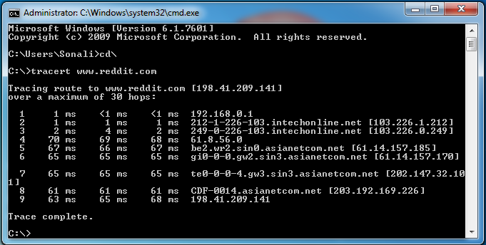

**Step 4:** Type tracert command and type [ipaddress](http://www.reddit.com) of reddit.com and press “Enter”.

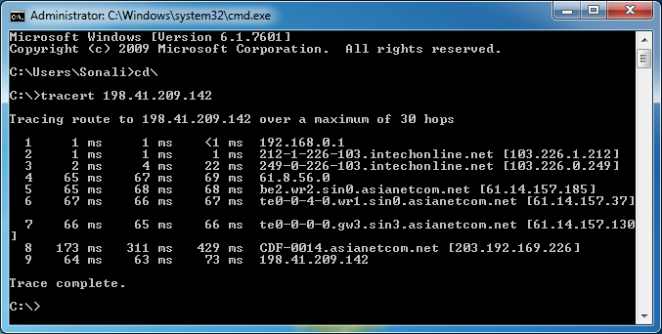

**USING EMAIL TRACKER**

**Step 1:** Open emailTracker.

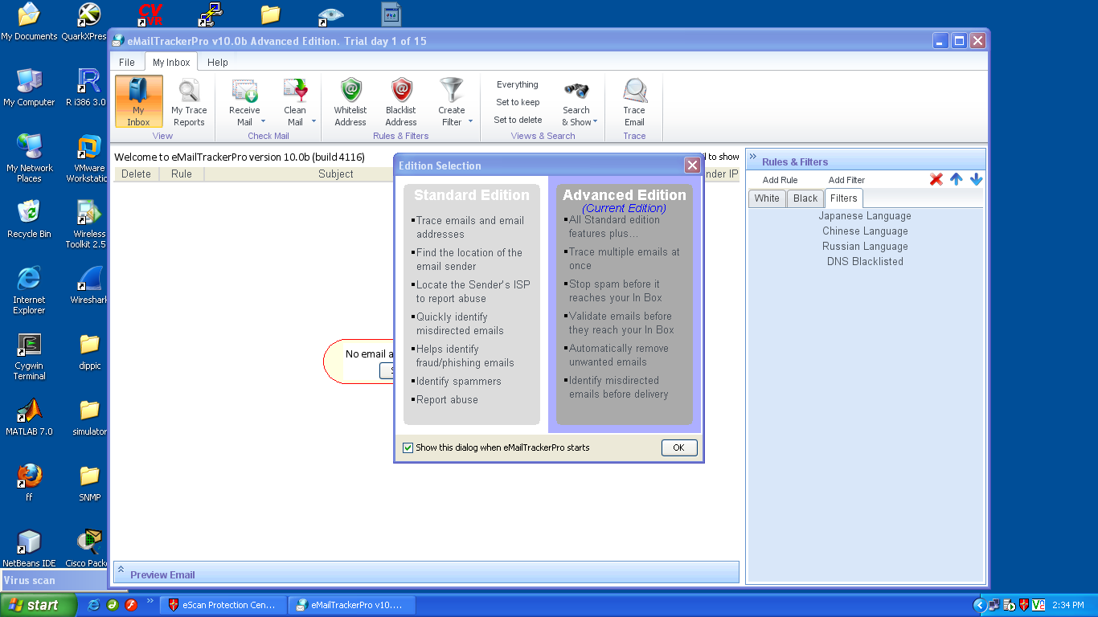

**Step 2:** Check if there are any reports generated previously.

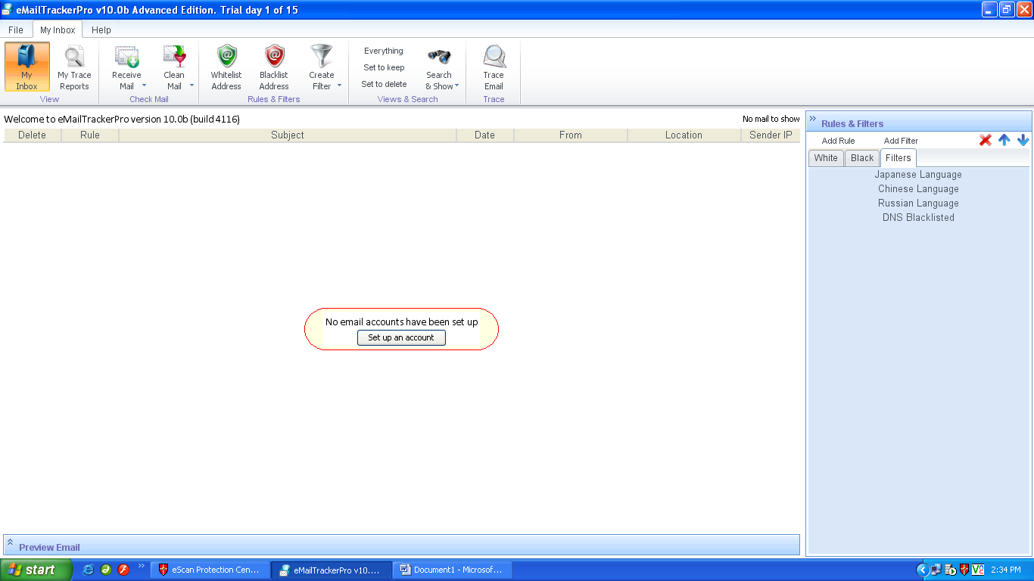

**Step 3:** Check for My trace Reports.

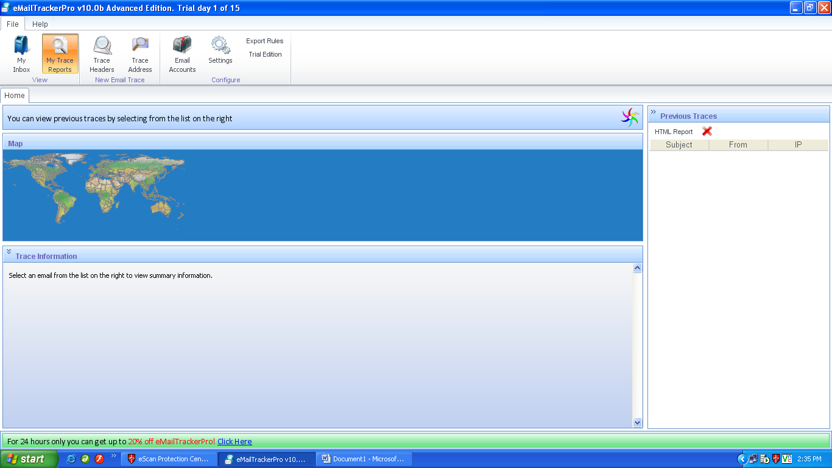

**Step 4:** Click on Trace address, a new window will open.

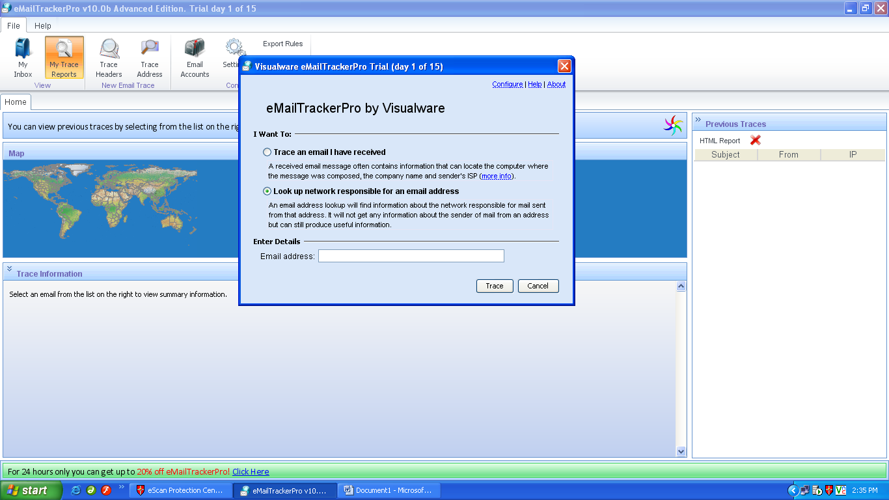

**Step 5:** Click on second option and enter email address you want to trace and click on trace button.

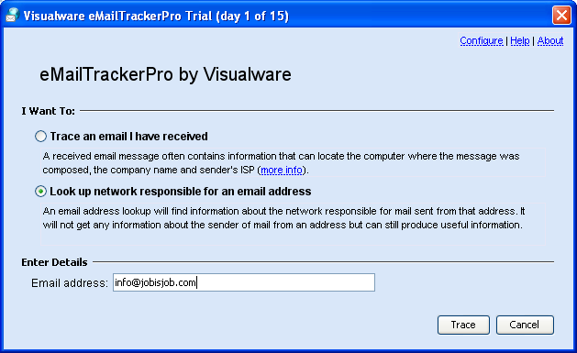

**Step 6:** The eMailTracker will search for the location and information about the email address entered.

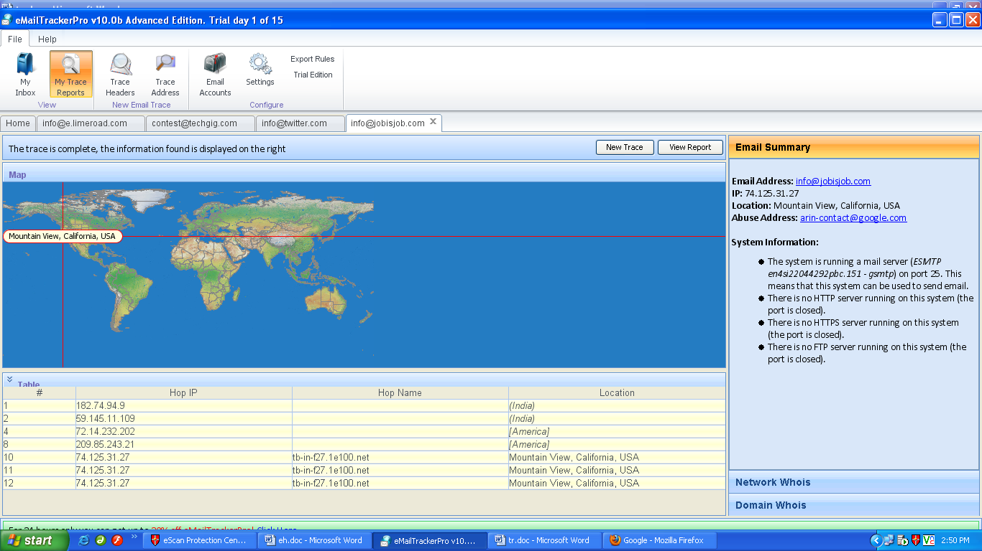

Figure: Location details and email summary.

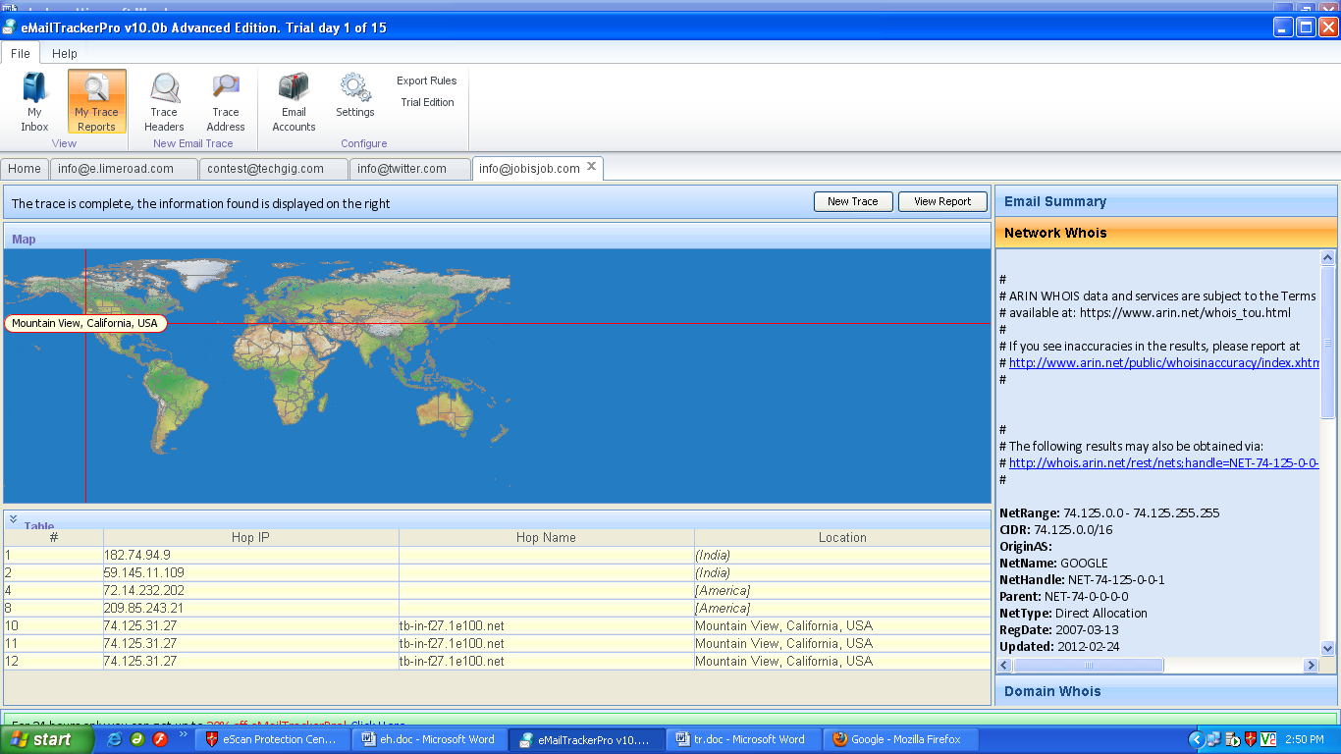

Figure: Location details and network summary.

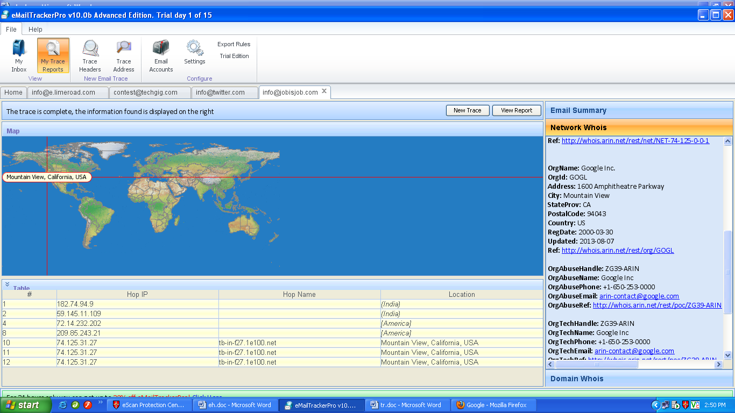

Figure: Location details and network summary.

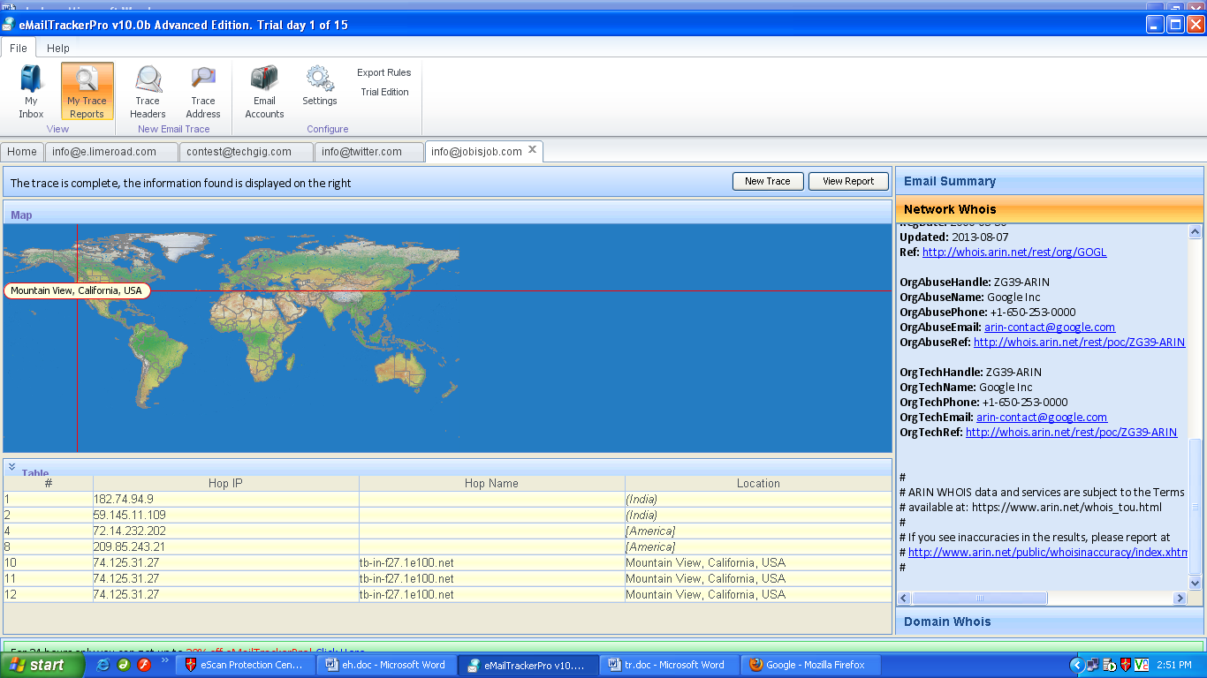

Figure: Location details and network summary.

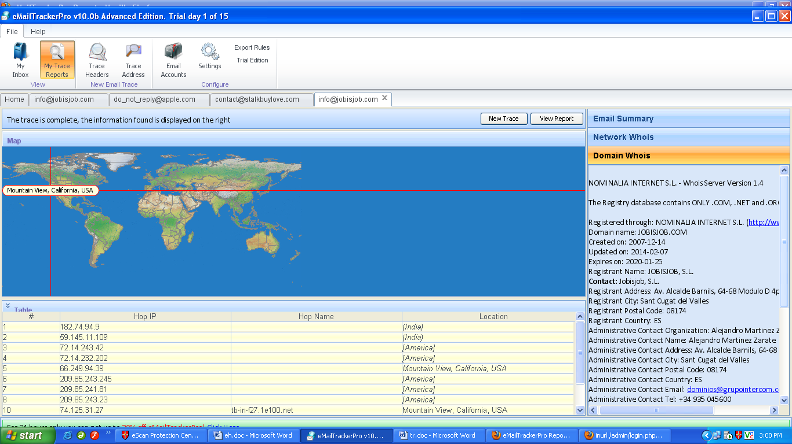

Figure: Location details and domain summary.

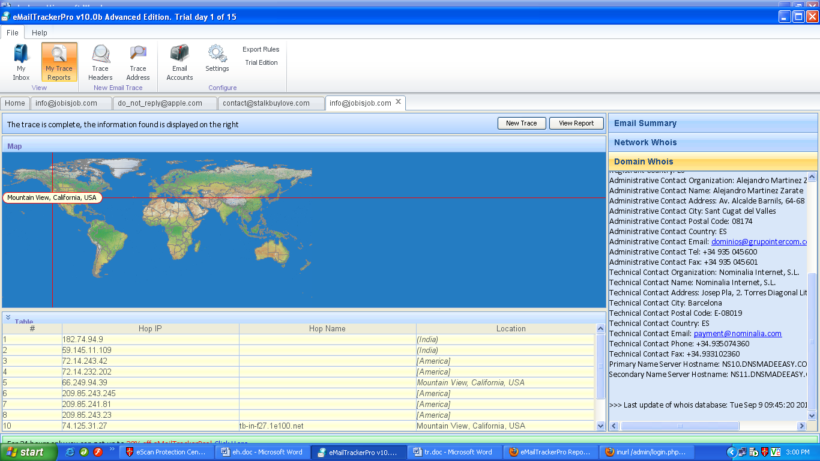

Figure: Location details and domain summary.

**Step 7:** Now click on View report and the following report will be generated in browser.

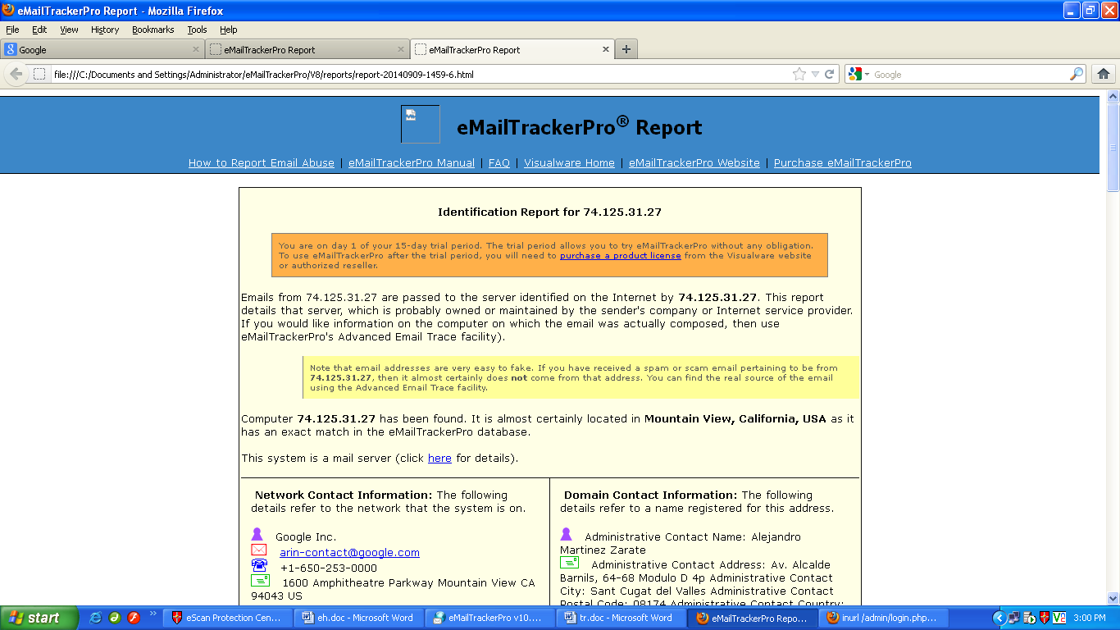

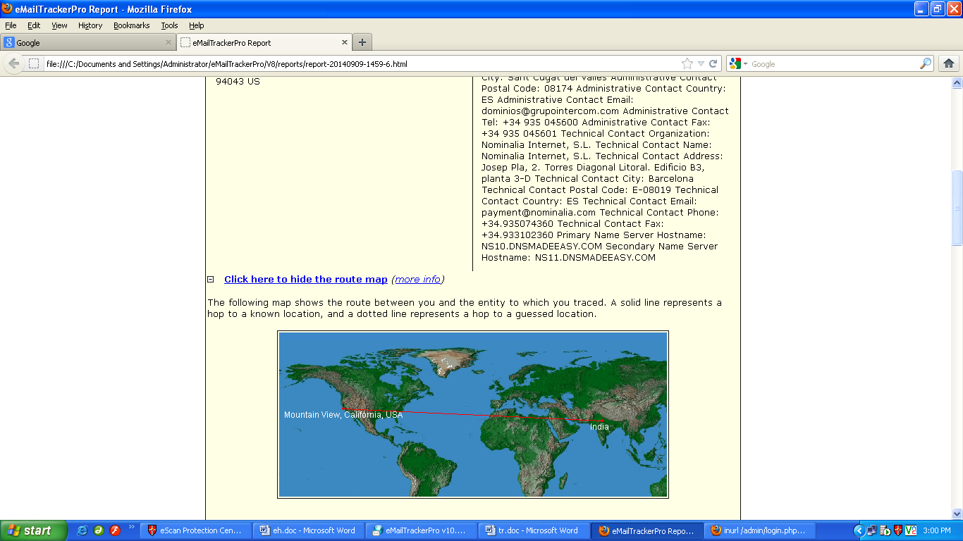

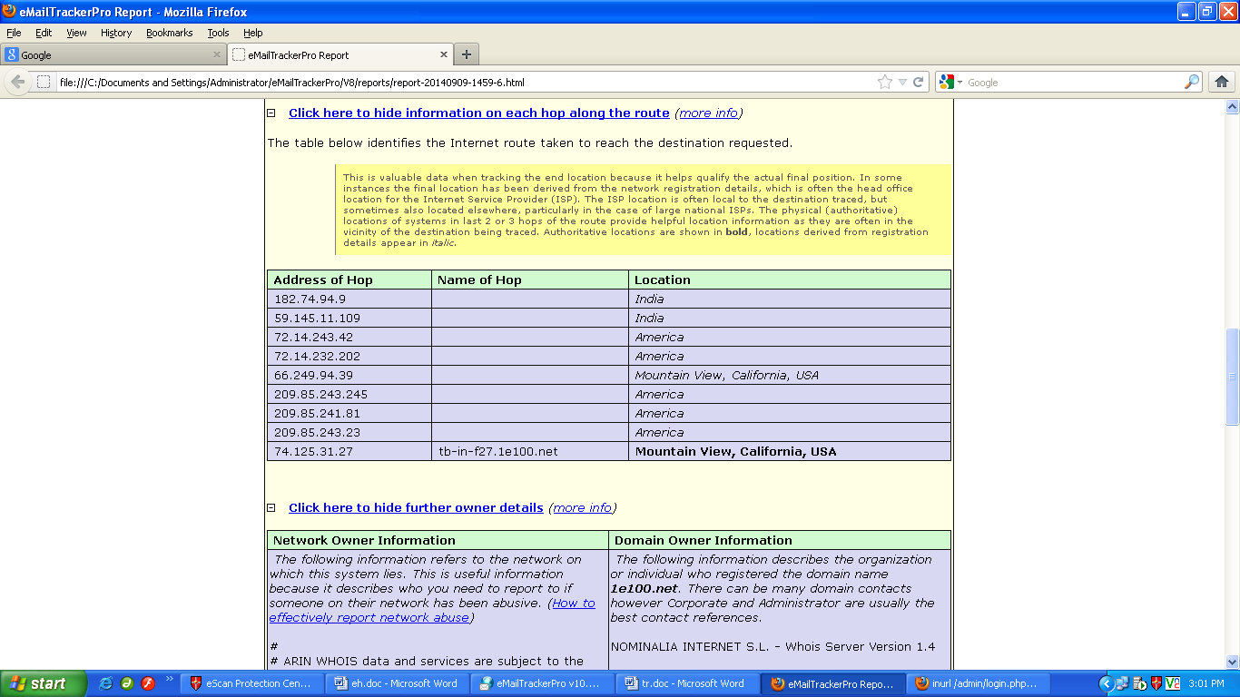

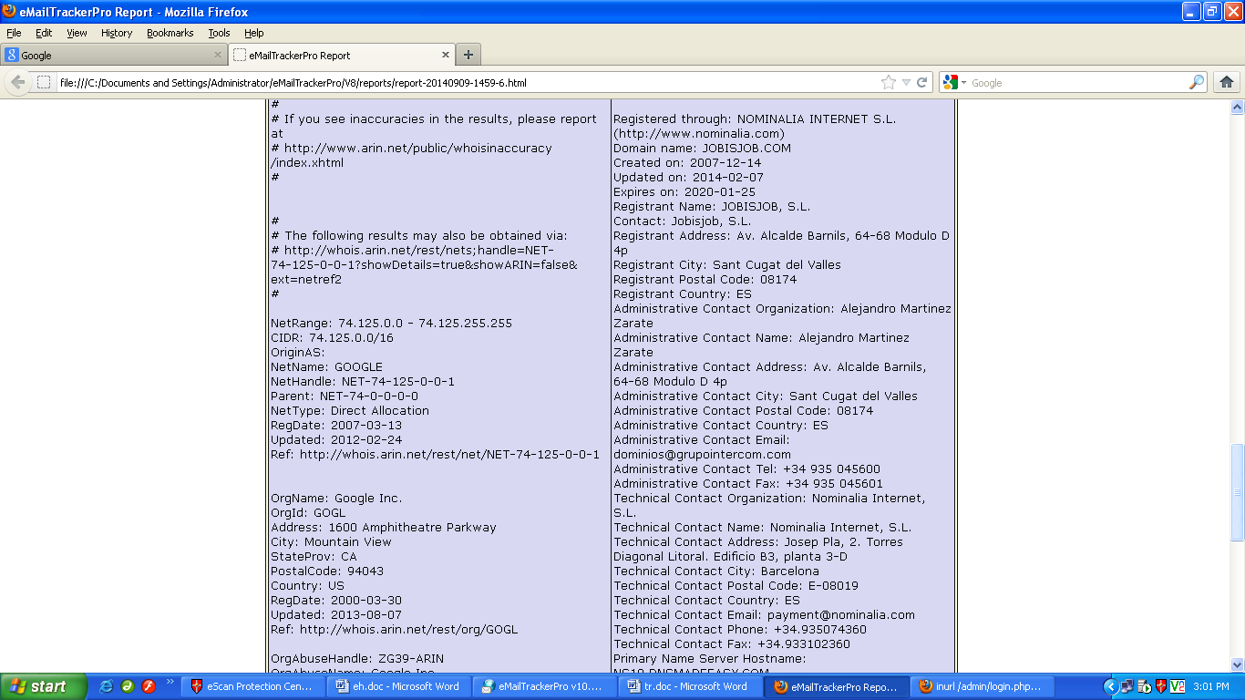

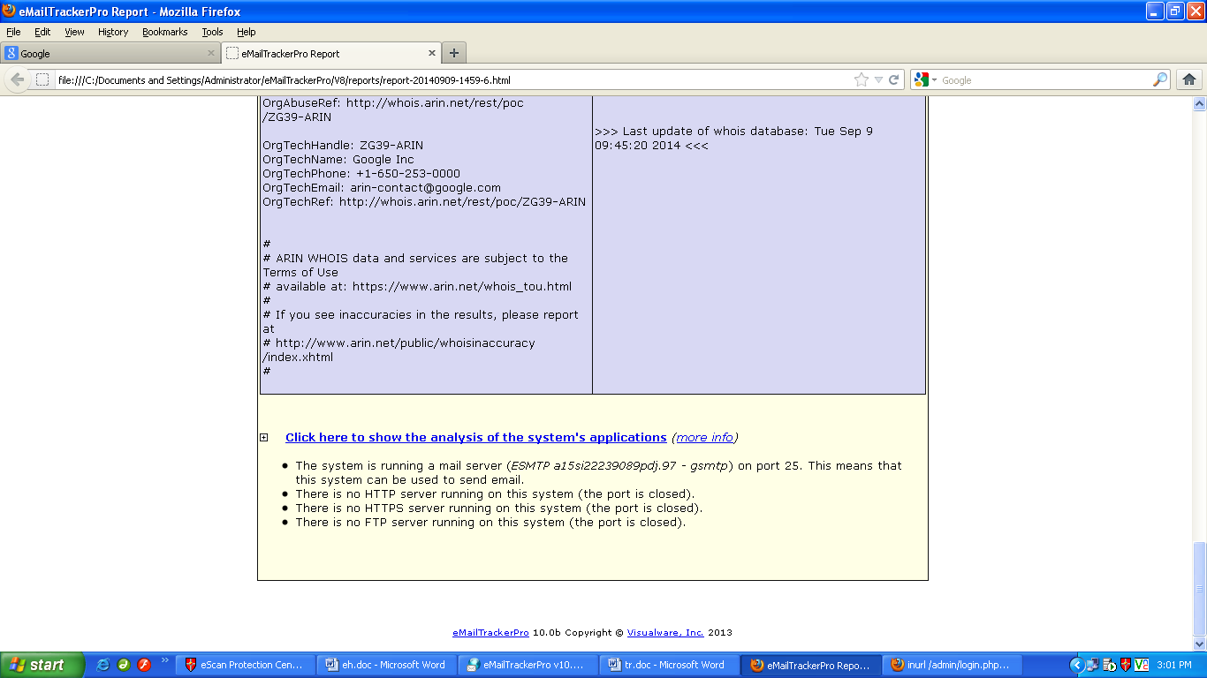

**HTTrack Website Copier**

Start > Programs >

* HTTrack Website Copier
* Click on 'Next' to create Project
* Give a name to project Click on 'Next'



* Click on ‘Add URL’ and give the UR  
* Any additional options that need t  
* Then click 'Next'
* By default, the radio button will be selected for Please adjust connection parameters if necessary, then press FINISH to launch the mirroring operation.



The mirroring of the site now begins. The site will be downloaded and be saved in the C:\My Web Sites\<Project Name>  



• Process of mirroring the website.



Once the Website Mirroring has been completed, you can click on the Browse Mirrored Website button and then browse the offline copy of the website.  



**SmartWHOis**

* SmartWHOis is used to perform WHOIS Footprinting against an entered IP Address or a Domain Name
* Run it from, Start > Programs > SmartWhois



Type an IP address, hostname, or domain name in the address bar



* Different queries will return different results.
* IP Address / Hostname Query results



**5. Ping**

This practical is used to find out the MTU of the destination machine.  

* We ping a computer using the ‘p
* To specify the data length in bytes we use –lswitch  
* To specify that the packet should not be fragmented we use –f



* We now have to adjust the –lvalue till we get a reply. The border where the reply is received is said to be its MTU



* Response is received at –l1472, hence the MTU size is 1472 Bytes



**TraceRoute using Ping**

* We can perform traceroute by using the –n and –Iswitches.
* -n means number of replies to show and –Imeans obtain reply from the machine in the next hop
* Open command prompt  
* Ping certifiedhacker.com –n 1 –I1

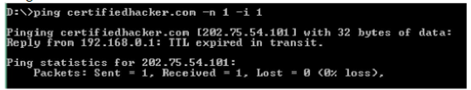

* Above, the local router replies back.
* Keep on increasing the I value until the certiedhacker.com site directly replies to the ping.
* At each I value, the device in the route will reply back



* At i=4, reply comes back from 121.241.80.6
* At i=14, the reply comes from the server hosting the certifiedhacker site



|  |  |
| --- | --- |
| Node | IP |
| 1 | 192.168.0.1 |
| 2 | 219.91.185.1 |
| 3 | 203.187.223.1 |
| 4 | 121.241.80.6 |
| 5 | 172.17.169.202 |
| 6 | Timed Out |
| 7 | 180.87.12.53 |
| 8 | 180.87.12.2 |
| 9 | 180.87.112.1 |
| 10 | 116.0.67.174 |
| 11 | 10.55.208.148 |
| 12 | 1.9.244.26 |
| 13 | Timed Out |
| 14 | 202.75.54.101 (Destination) |

**NSLookup**

* NSLookup is used to perform DNS Foorprinting by using the windows command **nslookup**
* When we type nslookup, it shows us our current DNS Server

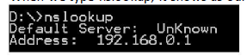

* To specify the DNS query type we want, we use the command

**set type = <recordname>** followed by the website name on the next line

**Set type = mx Certifiedhacker.com**

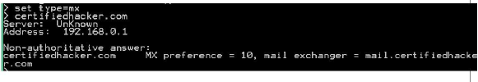

* We can set the **query type** as A, ANY, CNAME, MX, NS, PTR, SOA, SRV

**A Record**

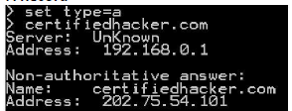

**SOA Record**

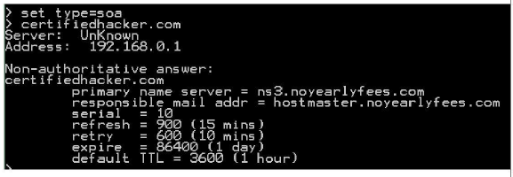

**NameServer (NS) Record**

